
Plugin creation XBMC.
Introduction.

Hello, I`m Vince.
Voinage to the Xbmc community, when i first started using Xbmc it was Xbox media player and the Tv schedules where awful and apparently in a world with more choice than ever over Tv content – I felt I had none. Forever damned to download via strange methods two hours before i wanted to watch something then FTP the file to my Xbox. Arrrrrrgh.
Then Xbmp evolved into the Xbmc that we all know and love, with it`s intuitive interface, clean design and powerful Python integration it was far in advance of all other media experiences and best of all it was running on the Xbox platform.
I would read through the Forum as a guest, probably like many of you, waiting for a new tv script then i would pounce and install, but this was in the early days of streaming and scripting. There was never really any good content. One morning, Plugins arrived – direct access to any media via a fast structured interface, it was great. A new era had dawned for streaming and the floodgates didn`t open, they burst. Unbehagen – founding father of plugins for Xbmc, had created a monster. Well done Hagen.
Soon after the Xbmc user could enjoy a myriad of Tv delights all streamed to the Tv in their main room, warm and comfortable. Instead of squinting at the cold unfriendly glare of their Pc monitor with an ear pressed to the speaker. Bad old days, never again, will i resemble a Mole caught on a riverbank toilet in the moonlight.
Stage 6, Joox, Surf the channel, Power flv – Choice was finally mine. It was a great time friends, people helping each other, a real community rallying together to gain the freedom of choice.
No adverts – just the right content at the right price – free.
Then, it , happened. Black Wednesday. Stage-6 closed. Surfthechannel changed it`s algorithms, powerflv chugged on but it was never the same.
I waited in the dark, hoping for new plugins but they never came. Alone in the dark with no Tv – I joined The Forum and began to arm myself with Python. Never again would i be beholden to the Tv execs, never again would i wait in the dark. NEITHER WILL YOU.

Selecting your Target.

Now that you have decided to get of your : Arse (English) – Bottom , Ass (English) – Donkey. Are you sitting comfortably ? Good, then we shall begin.
You will need :-
Yourself , Concentration , Determination.
Wireshark - http://prdownloads.sourceforge.net/wireshark/wireshark-setup-1.0.4.exe
Python - http://www.python.org/download/
Tutorial source code – Default.py , test.py

Selecting a target, sounds easy. I`ll just pick what i like. Great .
Don`t release it, enjoy it yourelf.
Just because you like Tropical fish videos doesn`t mean the Community will.
Try here : http://www.ovguide.com/ - plenty of streaming targets , eh ?
Now, check my requests thread here - http://xbmc.org/forum/showthread.php?t=33668 then check my Googlecode page - http://code.google.com/p/voinage-xbmc-plugins/downloads/list does one already exist ? Search the forum.
There are more than enough requests to go around. Don`t duplicate, what`s the point. You spend hours on a plugin only to find that one already exists and just needs fixing. Fix it – help a Voinage in distress.
Have you checked the threads and the Forum ?
Remember the 3 C`s :- Consider, Community, Content.
Install Python and find where you put the source code that came with this tutorial.
Right click on : - Default.py and select → Edit with Idle.
Don`t be afraid, this is the fun part.
Honestly, it is.

Plugin template : Breakdown.

This is just to familiarise yourself with the layout of the plugin template.
It`s not in depth – Python really can feel difficult.

Remember – it`s all about the Tabs.

Python is just like you and I, it has the ability to use information from other sources. If you don`t know anything about Python – you can read a book from a library.
So a Python library is a collection of useful functions that the main program can use.
To use them we need to import them, you will only use 5 at maximum for basic plugin creation.

import urllib,urllib2,re,xbmcplugin,xbmcgui

urllib – a collection of http routines.
urllib2 – a more advanced collection of http routines.
re – a collection of string manipulation routines.
xbmcplugin – specific Xbmc routines.
xbmcgui – specific Xbmc routines.
Without the above imports, python has no reference and the plugin will error and fail.
The next thing you will see is the ( CATEGORIES () : ) function.
This handy little function takes the stress out of Directory listing.

def CATEGORIES():
addDir("","",1,"")
addDir( "","",1,"")
addDir( "","",1,"")
addDir("","",1,"")

You define a function in python with the def command.
This function adds the first Directories that you see when you start the plugin.
Let`s break it down. Scan down the Plugin template.

def addDir(name,url,mode,iconimage):
u=sys.argv[0]+"?url="+urllib.quote_plus(url)+"&mode="+str(mode)+"&name="+urllib.quote_plus(name)
ok=True
liz=xbmcgui.ListItem(name, iconImage="DefaultFolder.png", thumbnailImage=iconimage)
liz.setInfo( type="Video", infoLabels={ "Title": name } )
ok=xbmcplugin.addDirectoryItem(handle=int(sys.argv[1]),url=u,listitem=liz,isFolder=True)
return ok

I`m not going to go into too much detail here, when you call the addDir() command you are calling the above function. All that is happening is a name, url, and image are being passed to Xbmc in a format it likes and it`s being told to display it.

name = The name of the Directory, either a string or the product of a scrape.

Python likes strings or stored strings.
To make a string, give it a name then type your string in quotes.

a= ` this is a string’ , notice how it turns green.

For the name that addDir needs you can either pass it a string.

addDir(`string’, ’’ , 1 , ’’) or a stored string addDir(name, ‘’ , 1 , ’’ )

We will examine stored strings later.

url = The web address, either a string or the product of a scrape.

As above pass either a string ‘ http://www.testing.com’ or a stored url string – url.

Next on the list is:

mode = Where in the program to jump to .



Look at the bottom of the Template.

if mode==None or url==None or len(url)<1:
print ""
CATEGORIES()

elif mode==1:
print ""+url
INDEX(url)

elif mode==2:
print ""+url
VIDEOLINKS(url,name)

We have 3 modes here you can have as many as you need.

mode 0 = CATEGORIES()
mode1= INDEX(url,name)
mode2=VIDEOLINKS(url,name)

So in the CATEGORIES () : function, we call addDir(‘’,’’,1,’’) which tells the plugin to move on to mode 1 = INDEX(url).

Tell Xbmc to add the first Directories then move on to INDEX function.

See it`s not awful.

The last term here is :

Iconimage = An image for display with the Directory or link, either string or stored string.
Basically a thumbnail.

addDir (name, url , 1 , ’http://testing.com/image.gif’) or
a stored string addDir(name, url , 1 ,thumb )

Xbmc can handle pretty much all image formats : jpg ,gif, png etc

The addLink(name,url,iconimage) is exactly the same except the isfolder= option is set to false to tell Xbmc that this is a video link and not a folder.

The next Function is the ( INDEX (url) : ) this opens the webpage of your chosen website, pretends to be a browser, reads it, stores the page and then scans the page for links to the sacred video files.

def INDEX(url):
req = urllib2.Request(url)
req.add_header('User-Agent', ' Mozilla/5.0 (Windows; U; Windows NT 5.1; en-GB; rv:1.9.0.3) Gecko/2008092417 Firefox/3.0.3')
response = urllib2.urlopen(req)
link=response.read()
response.close()
match=re.compile('').findall(link)
for thumbnail,url,name in match:
addDir(name,url,2,'')

We are going to call on the urllib2 library not the Urllib library to connect to the web page because we can spoof the website into believing that the plugin is a real person using a browser.

req = urllib2.Request(url)
req.add_header('User-Agent', ' Mozilla/5.0 (Windows; U; Windows NT 5.1; en-GB; rv:1.9.0.3) Gecko/2008092417 Firefox/3.0.3')

url - is the web address that we passed during the previous CATEGORIES () -
addDir(name, url , 1 ,thumb )

We have added a header, User-agent.
This allows Python to pretend to be anything else, Firefox, Internet Explorer,Ipod,Phone,Veoh.
We can send any headers here using the same format.
Just copy the req.add_header and put it under the other one.

Some sites need specific headers to access their information.
This pretends to be the latest Firefox.

req.add_header('User-Agent', ' Mozilla/5.0 (Windows; U; Windows NT 5.1; en-GB; rv:1.9.0.3) Gecko/2008092417 Firefox/3.0.3')
req.add_header('Content-type', 'octet-stream/flv')

response – adds the req calls and causes connection with the webpage.

response = urllib2.urlopen(req)
link=response.read() - Holds the webpage that was read via the response.read() command.
response.close() - Closes the connection after we have read the webpage.
match=re.compile('').findall(link)
for thumbnail,url,name in match:

link is the holder for the page (url from CATEGORIES) that was read.
We close the open connection as we have the page and want to save memory.

Now we scrape the screen for the relevant information.
We are using the re library here:

match=re.compile('').findall(link)

match is the holder for the compiled bits of information we have scraped.
We will explore this in depth in the next part of the tutorial. Just familiarise yourself for now.

Open http:/xbmc.org/forum/register.php in your browser ( I use firefox ).

Right click and select View page source.
Scroll right down to the bottom of the page do you see : -

<div class="smallfont" align="center">

to scrape the words smallfont and center we would use –

match=re.compile('<div class="(.+?)" align="(.+?)">').findall(link)

so match now holds – smallfont and center.
The order matters so remember smallfont is first, center is second.
Imagine that this was the url and name of a video.

match[0] = smallfont
match[1] = center

Lets move on.

for ? in match: Gets all the information stored in match and creates multiple links or directories on your screen.

for url,name in match:
addDir(name,url,1,’’)

url = The first thing held in match
name = The second

You can call them whatever you wish.
So a directory will be created named = center with the url = smallfont
As you can see the VIDEOLINK() function is just the same really, except for addLink instead of addDir. Minimize the template, open your browser, right click → edit with idle - on test.py and lets really do something. If you are still unsure about what you have read, re – read.

Test, test, test again.

Right, let`s have some fun.

Open your Browser ( I use Firefox for the tutorial)
Ctrl & click the link : - http://www.ovguide.com/
Scroll down – see TV DASH, that`s the fellow for this tutorial.
Click it or Ctrl & click the link : - http://www.tvdash.com/
Once it`s open – Bookmark it.

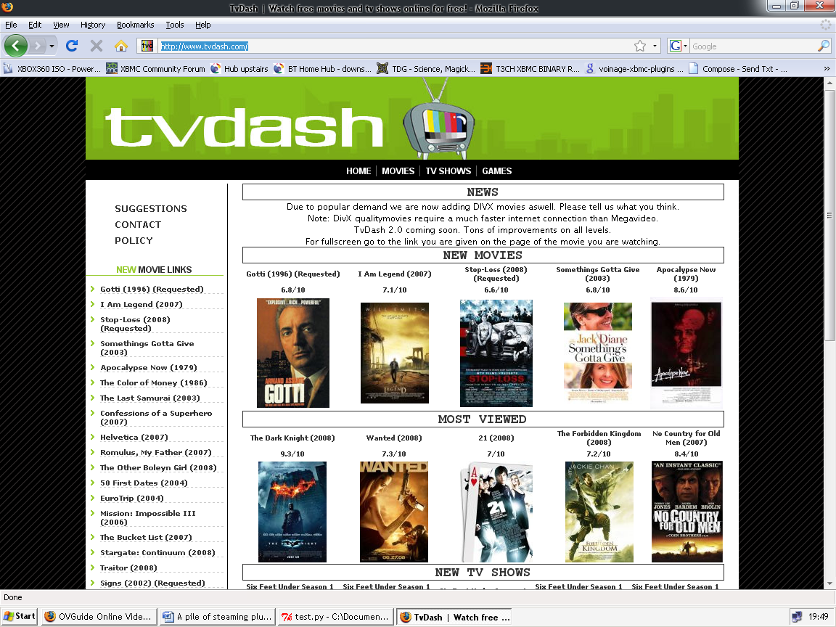

Excellent Choice, at first glance we have thumbnails for the movies & tv – great for Xbmc.
The site looks clean and tidy – great for grabbing urls, without headaches.

Look at the top center of of the screen, Home, movies, tvshows,games.
They will become our main directories and as there are only two that we need, we will add them manually.

Before we do that lets get the scraping and testing done.
Click on the ‘ MOVIES ‘ link.

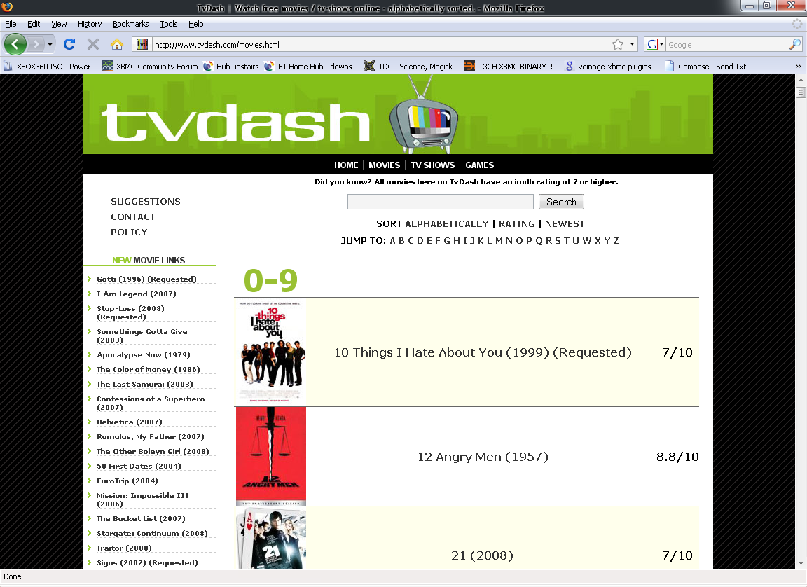

A lovely list of movies, ha, nothing makes me feel more like a Pirate than this – Aaargh Jim`lad.

Hoist the test.py.

Remember the name of the first movie listed here, we will need it later.

First copy the url from the address bar of your browser.
Right click and copy.
Click to restore the test.py window you will see this or something like it.
import urllib2,urllib,re

url=' Delete me'

req = urllib2.Request(url)
req.add_header('User-Agent', 'Mozilla/5.0 (Windows; U; Windows NT 5.1; en-GB; rv:1.9.0.3 Gecko/2008092417 Firefox/3.0.3')
response = urllib2.urlopen(req)
link=lemon.read()
response.close()
match=re.compile('Delete me 2').findall(link)
print match

Click and delete the text url=' Delete me' → url=' '
Replace it with the url you have stored. Ctrl & V.

url=' http://www.tvdash.com/movies.html’

Press ‘ F5 ’ – which is really run module in Python terms.

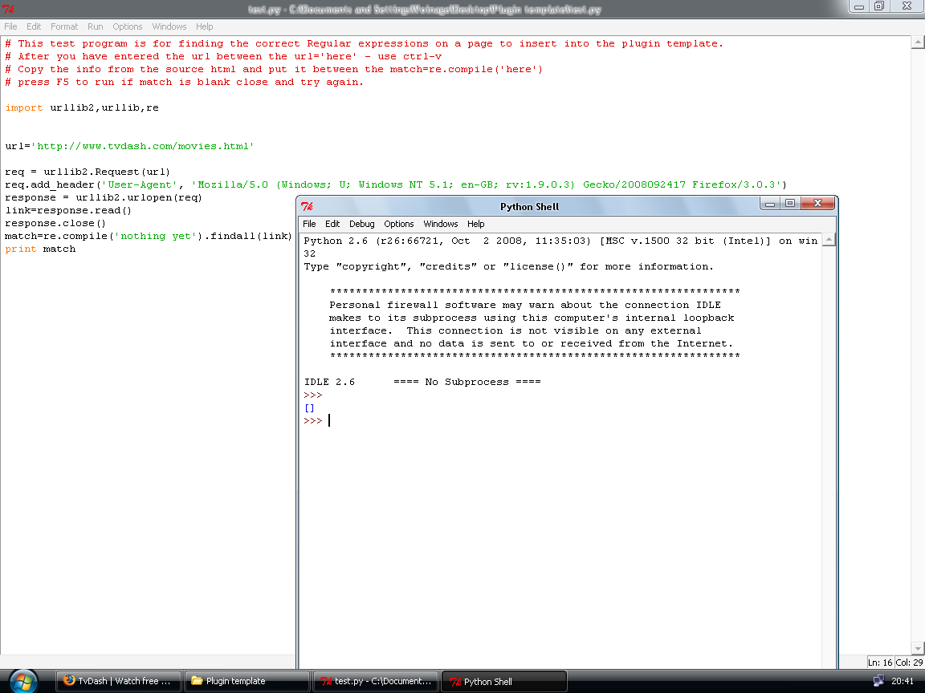

The parentheses are the graphical representation of what`s stored in match. In this case, nothing, yet.

The ‘ Print match ‘ command causes the display, you can print any variable or string.
Remove it by putting # in front of it #print match see how it turns red.

Any text you put after a # character becomes a non-useable note ! Great for adding your plugin title.

The reason for this is that we haven`t provided any regular expression to scrape the data, we will soon.

But for now, we have a nice Python shell open.

All commands are case sensitive so type exactly what you have in test.py only.
Type ‘ print response.info() ‘ ←ENTER this will bring up the server response from the website.

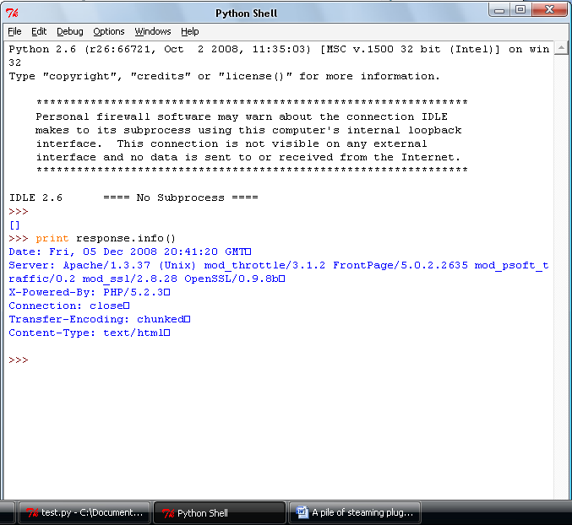

See how powerful Python is ?
This is really useful, but not just yet.

Sometimes Cookies that are required to access sites reside here and can be accessed and manipulated to your benefit.

Commands and tabulation is what Python is all about.

Back Sir/Madam, back I say, to your browser and let`s look at the source of the page.
Press Ctrl & U to view the page source.

At this point it is very easy to be put off, don`t be, once your eye is in – it becomes second nature. Honest.

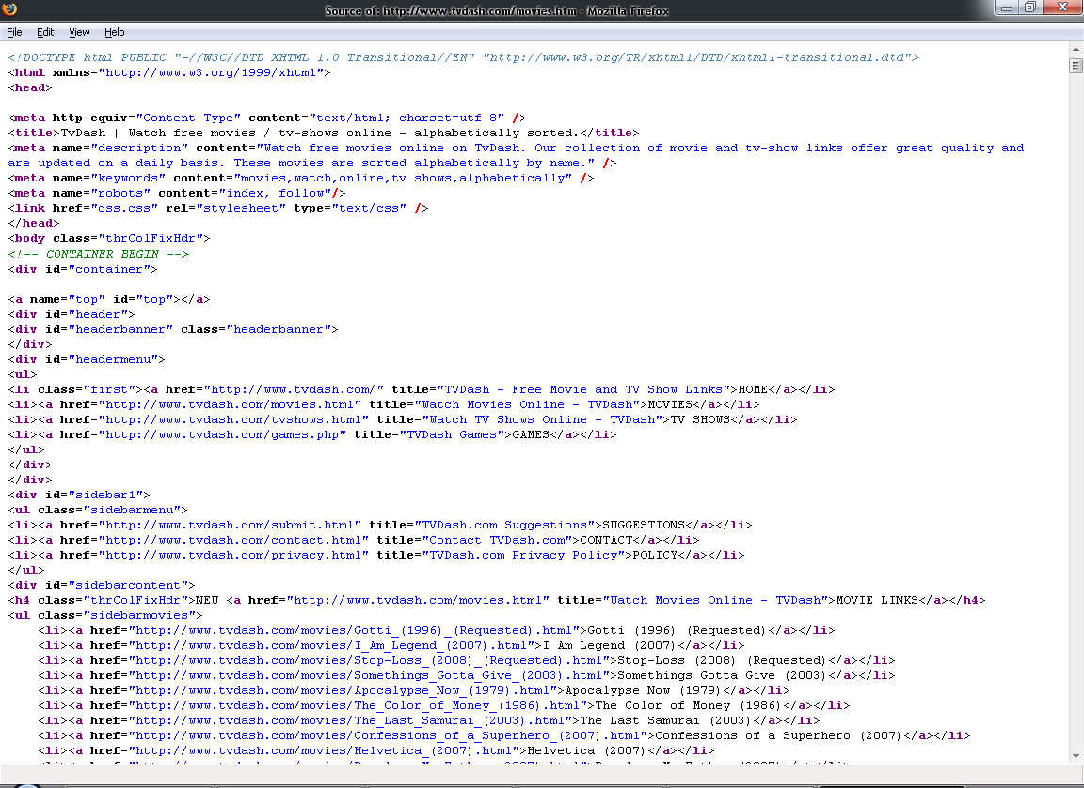
Hmmm ....... Press Ctrl & f to bring up the search and enter the name of the first movie.
10 things i hate about you , Now this is more like it.
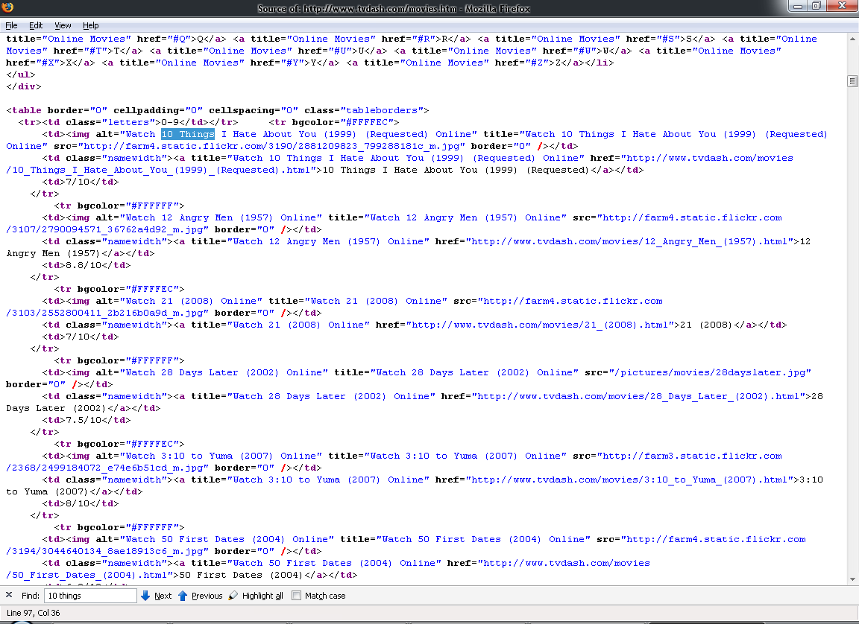
The name, iconimage (Thumbnail), url are all here. Great.
First, maximize your Python shell.

In your Python shell type : - link ← ENTER

Once it has completed, you will have a display of the webpage ready for scraping.

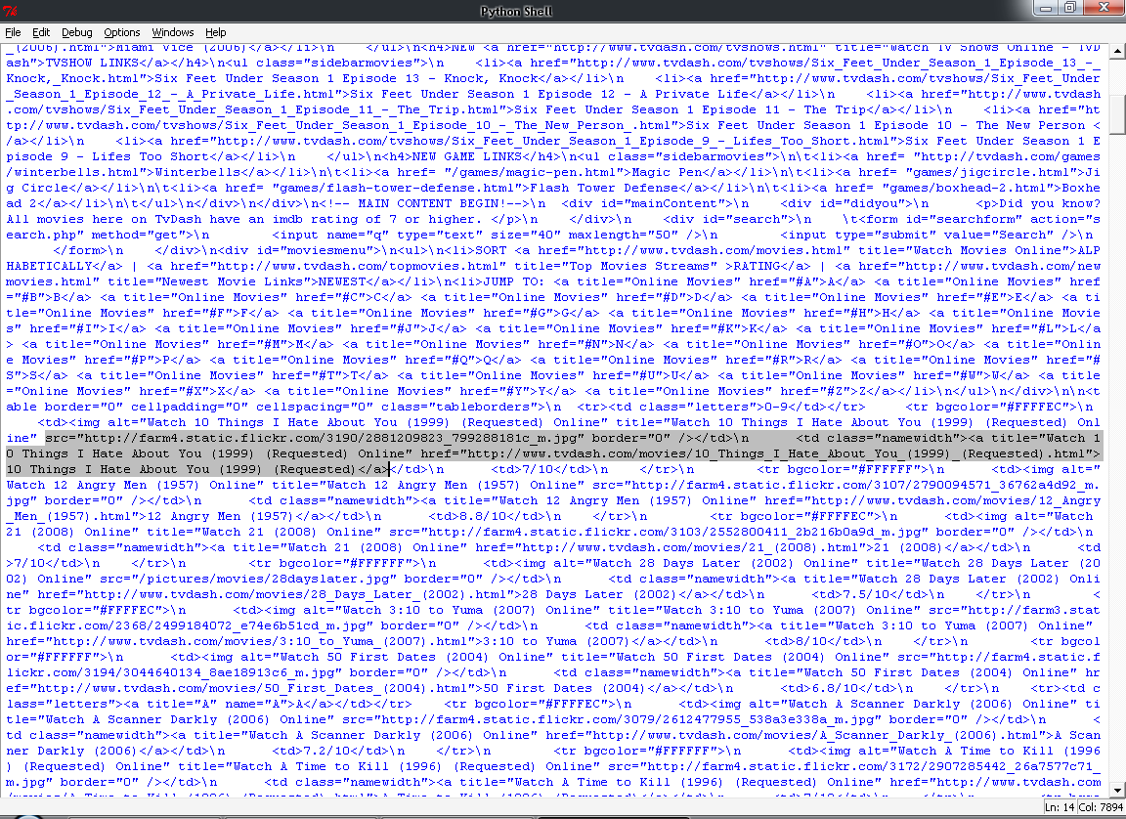

Press Ctrl & f to bring up the search and enter 10 things I hate about you ←

You will see the above section. The highlighted area is exactly what we need.
It has the thumbnail,name and url.

src="http://farm4.static.flickr.com/3190/2881209823_799288181c_m.jpg" border="0" /></td>\n <td class="namewidth"><a title="Watch 10 Things I Hate About You (1999) (Requested) Online" href="http://www.tvdash.com/movies/10_Things_I_Hate_About_You_(1999)_(Requested).html">10 Things I Hate About You (1999) (Requested)</a>

The yellow areas are what we need for the tutorial.

http://farm4.static.flickr.com/3190/2881209823_799288181c_m.jpg → Thumbnail
http://www.tvdash.com/movies/10_Things_I_Hate_About_You_(1999)_(Requested).html → Url
10 Things I Hate About You (1999) (Requested)</a> → name

The Red section wouldn`t really look nice displayed for a movie name, what do you think ?
To scrape the text we need to show Python what to take and where it is.
Have a go at highlighting that whole section, NOT JUST THE YELLOW BITS , hold your left mouse button and drag it across the section. Then press Ctrl & c to copy to clipboard.
Close your Python shell and restore your test.py.

Place your cursor in between the ‘ ‘ of the match=re.compile ( ‘ ‘ ).findall(link)
Press Ctrl & V. You should see this.

match=re.compile(‘src="http://farm4.static.flickr.com/3190/2881209823_799288181c_m.jpg" border="0" /></td>\n <td class="namewidth"><a title="Watch 10 Things I Hate About You (1999) (Requested) Online" href="http://www.tvdash.com/movies/10_Things_I_Hate_About_You_(1999)_(Requested).html">10 Things I Hate About You (1999) (Requested)</a>').findall(link)

The text between the single quotes is green because Python recognizes a string and highlights
green.

Green = good
Red = bad , providing the code was not after the # character. Python uses this to mark notes.

Future reference.
If the scrape has single quotes in it - src= ‘ http://tester.html ‘ you will need to change the wrapping quotes – match=re.compile( ‘src= ‘ http://tester.html ‘ ‘ )
to match=re.compile( “src= ‘ http://tester.html ‘ “ ) to not confuse Python.

Okay, let`s scrape that site.

There are many useful regular expressions that Python understands but generally for basic site scraping you only need - brackets around what you want to capture then delete the text and replace with:

(.+?) – Yep, it really can be that simple – sometimes.

Let`s just say it means take everything inside the brackets – it is a basic tutorial. He,he.

When trouble brews and trust me , it will. Try here for really in depth help – I did.

http://www.amk.ca/python/howto/regex/
http://www.python.org/doc/2.5.2/lib/re-syntax.html This will explain the true meaning.
http://www.python.org/doc/2.5.2/lib/module-re.html
http://www.regular-expressions.info/python.html

The scraping, following the tutorial - put brackets around what you want to capture then delete the text and replace with (.+?) – basically replace the yellow highlights with (.+?) and we get :

match=re.compile('src="(.+?)" border="0" /></td>\n <td class="namewidth"><a title=" .+? " href="(.+?)">(.+?)</a>').findall(link)

So here we have scraped the image,url and name. You noticed didn`t you.
The Red Highlighted section has been replaced with .+? that is because that text will not be the same for every movie on the page.

If the movie is ‘ Friday 13th ‘ it would say ‘Watch Friday 13th’
not ‘Watch 10 things I hate about you’ so we tell python to skip it with .+?

– No brackets, no scrape.

Let`s move on . .you should end up with thi . . .
What do you mean you`re not ready.
Okay go back and re-read the last section.
Honestly people today, wouldn`t have happened in my day . .

Ready now ?

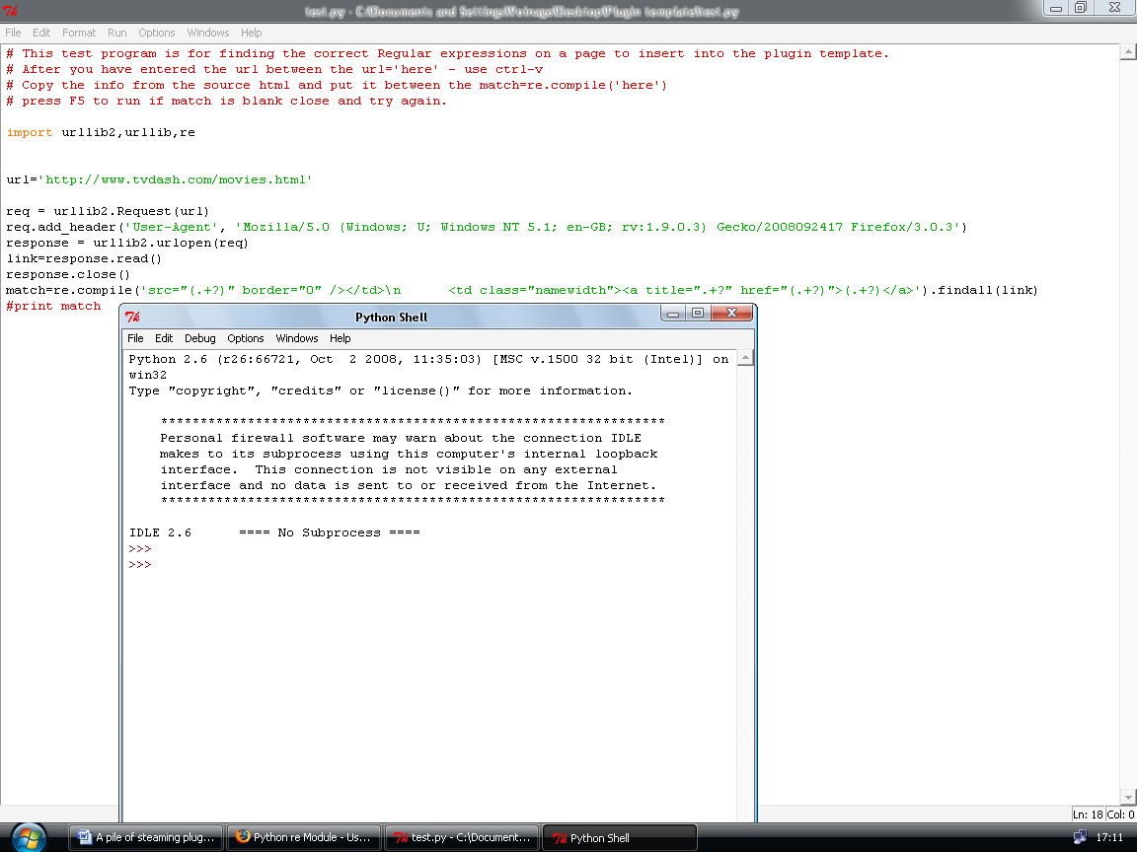

Maximize your Python shell and type >>>Match ←ENTER

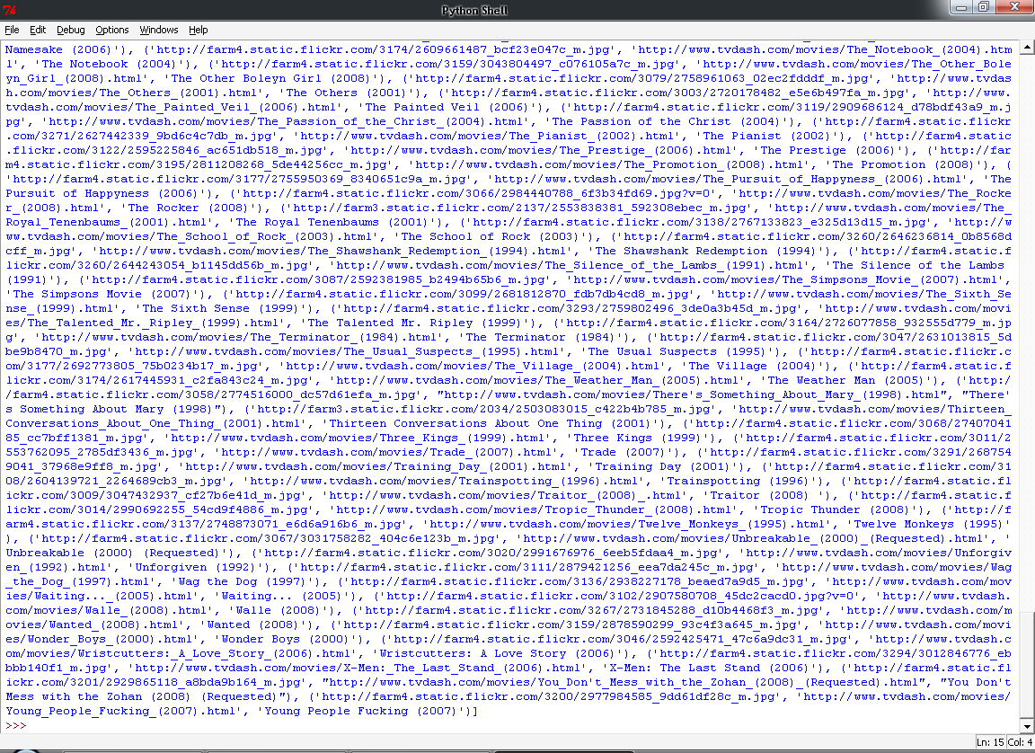

Houston, we have an RE match.

The variable match now holds the information we wanted in the form of a Tuple.

 No not a Tribble – bad Trekkie.

For information on tuples try here : http://en.wikibooks.org/wiki/Python_Programming/Tuples

How many matches did we get ?
Let`s use the len() command – length of variable.
Type >>> len(match) ←ENTER
We get >>>251 so our RE pattern matched 251 times. That`s 251 movies.

Python always starts at zero. So the first match is match[0] not match[1]
That means that the length really is 250, so the last item is match[250] or match[-1]
A negative index number goes backwards, handy eh.
Have a go, try a few things >>>match[10] or match[-10] etc
We have 3 things stored in match try : match[0][0] hmmmm


Putting it together.

Well where does that leave us ?

So far we have scraped some information and stored it in the variable match.
We have established that information stored in python variables can be accessed individually.
We have established how to read a webpage contents then store and display them in python.

Let`s put it together..

Restore Default.py and put your cursor between the quotes of the name area.
Type ‘ MOVIES ‘ and again with url area this time restore test.py and copy, using Ctrl & c, the
url=' http://www.tvdash.com/movies.html’ text. Go back to Default.py and paste using Ctrl&V between the single quotes in the url area.

addDir("MOVIES","http://www.tvdash.com/movies.html",1," http://reggiebibbs.files.wordpress.com/2007/12/the-movies360-crop.jpg")

If you would like Xbmc to display a custom thumbnail for the MOVIES directory.
Put a url to an image or a path to an image, inside the single quotes in the thumbnail area.
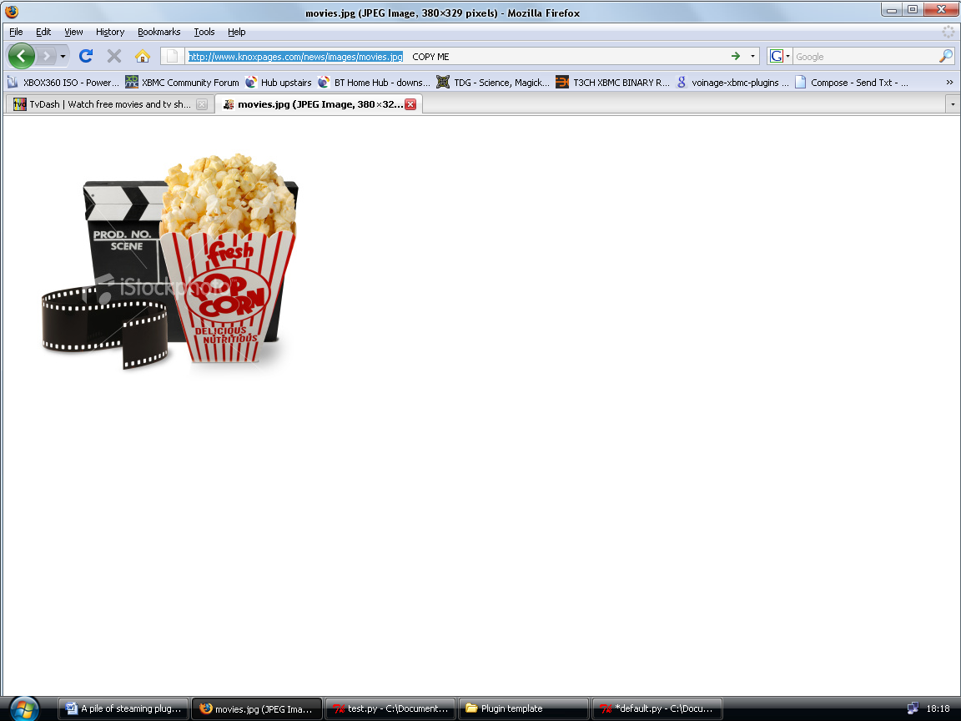

The path should be on your xbox not your PC.
Q:/XBMC/PLUGINS/VIDEO/YOUR PLUGIN/IMAGES/Movie.png
So the previous.

addDir("MOVIES","http://www.tvdash.com/movies.html",1," http://reggiebibbs.files.wordpress.com/2007/12/the-movies360-crop.jpg")

Adds a directory folder named MOVIES to xbmc with the url http://www.tvdash.com/movies.html moving to mode=1 with the thumbnail http://reggiebibbs.files.wordpress.com/2007/12/the-movies360-crop.jpg

Let`s move to mode=1 which is INDEX(url)
Go to test.py and copy the text between the single quotes of match=re.compile(‘ ’)
Go to Default.py and delete the text between the match =re.compile(‘’) quotes and paste.

We now should have:

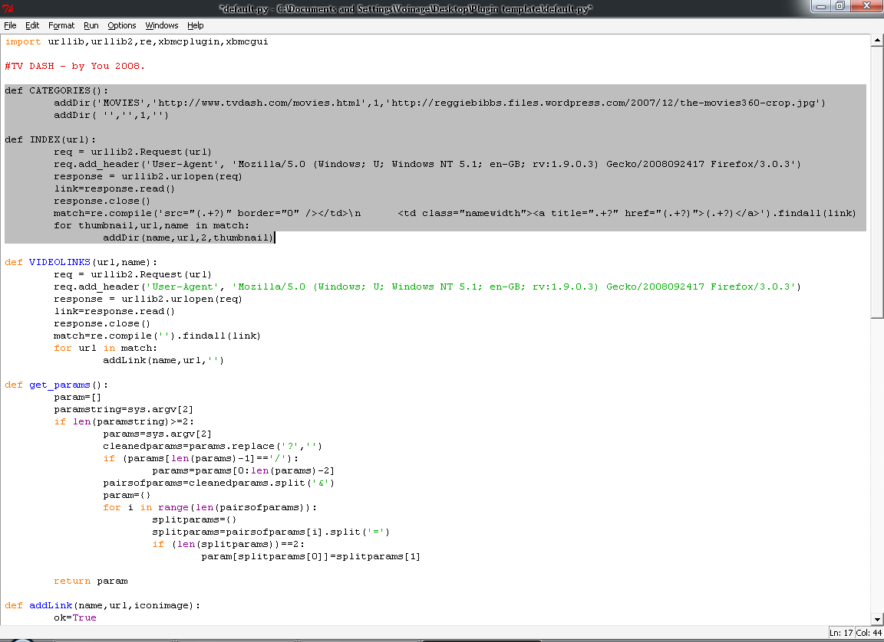

for thumbnail,url,name in match:
addDir(name,url,2,thumbnail)

Here we go, for every occurrence of the Tuple (thumbnail,url,name) found in match add the directory :- MOVIE NAME, URL, MODE=2, THUMBNAIL to Xbmc.

Lets go to mode=2 which is VIDEOLINKS(url,name) :- We are passing the Url and the name from the INDEX(url) - which only recieved the Url from CATEGORIES()
– along to VIDEOLINKS (url,name) whatever lives in the brackets is passed along.
If you change this remember to change the mode area also !
Close Python shell to clear the shell page.
Restore test.py and restore your browser window.
Right click on the first movie link and Copy Link location.

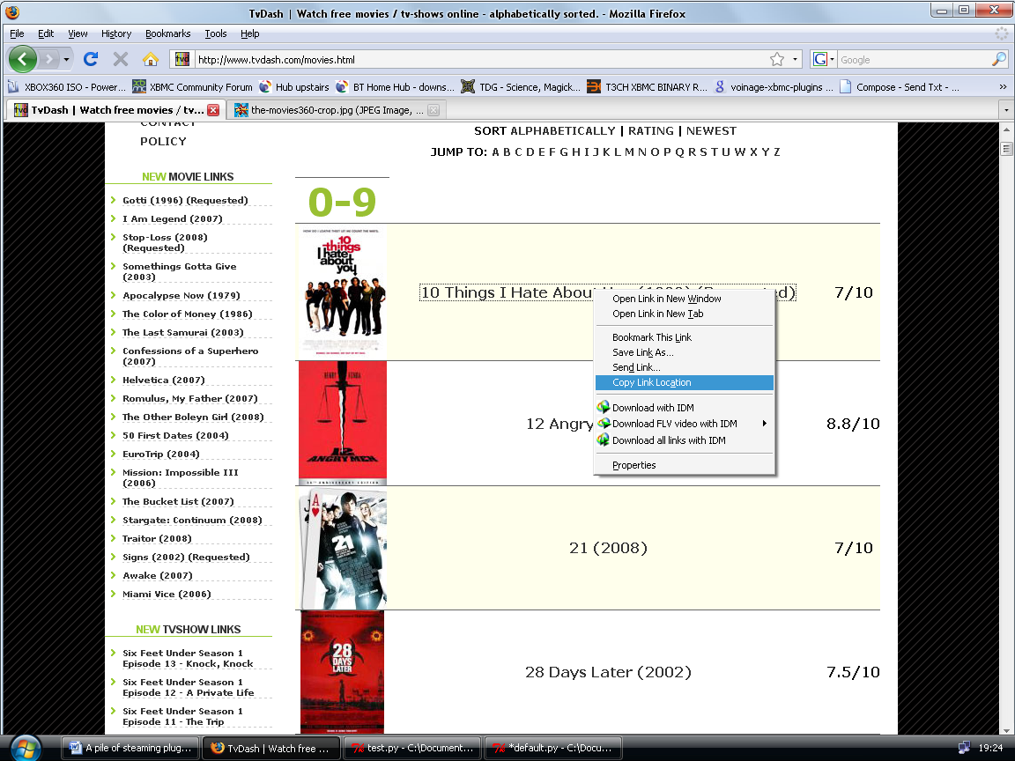

Before we move on it`s worth pointing out that nearly all video on websites is hidden or at least never just a direct link : - http://tvdash.com/10_things_i_h8_aboutyou.flv

They will generally be hosted elsewhere by a provider such as:

Megavideo, Tudou, Youku, Youtube, Google, Veoh.

They require a lot more handling than direct links, but the routines are provided for you.
Rather than creating a class for you to import. (Well I did, but this is a basic tutorial)

Just copy and paste them into Default.py as functions.

Paste the link into your restored browser address bar and press ENTER

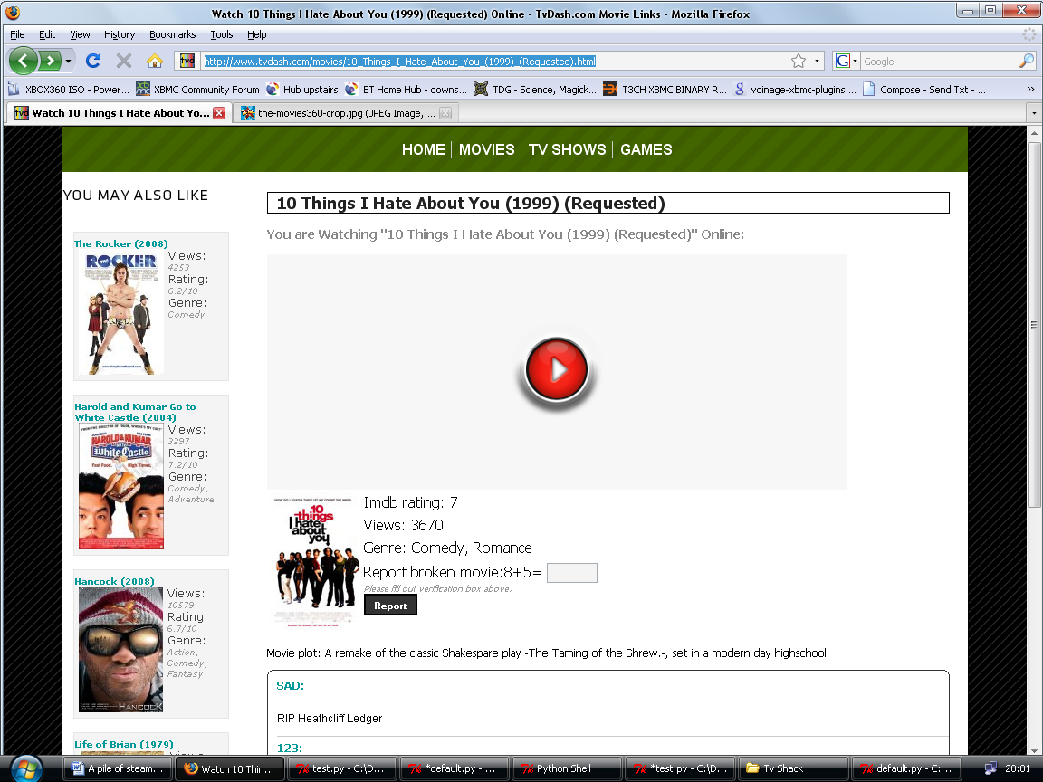

Well, what do we look for ?

See the evil red play button. This equals Megavideo – bane of streaming with it`s cut offs.

It`s like the eye of Sauron isn`t it



Megavideo is very tricky to resolve but thanks to Coolblaze we can do it rather well.

Select and restore test.py
Delete the url text inside the single quotes and paste in the new url with Ctrl & V
We get : url=’http://www.tvdash.com/movies/10_Things_I_Hate_About_You_(1999)_(Requested).html’
Press ‘F5’ – to run test.py
Type >>>link ←ENTER

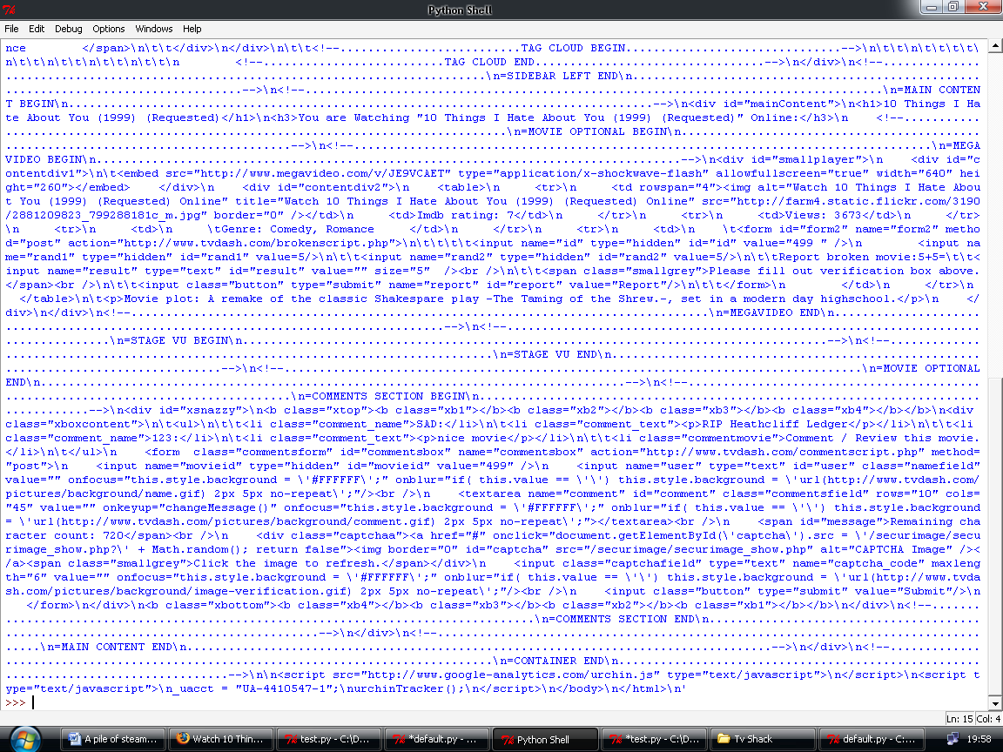

Ctrl & F and type ‘ Megavideo’ we know it`s megavideo because of the Red play button.

Look for :

<embed src="http://www.megavideo.com/v/JE9VCAET" type="application/x-shockwave-flash"

As before we need the yellow not the red.

The above is all we need for the RE string so highlight it in the Python shell window and copy it with Ctrl & C and close the python shell.

Restore the test.py and delete the text inside the single quotes of match=re.compile(‘ ’)
paste the copied text.

You should have :

match=re.compile(‘<embed src="http://www.megavideo.com/v/JE9VCAET" type="application/x-shockwave-flash"’).findall(link)

Set your RE :

match=re.compile(‘<embed src="(.+?) " type=".+?"’).findall(link)

So we will take the url to the video, skipping the type= ’.+?’ , try your own RE expressions.
Close the Python shell then select test.py and press ‘ F5 ’ and type >>>match

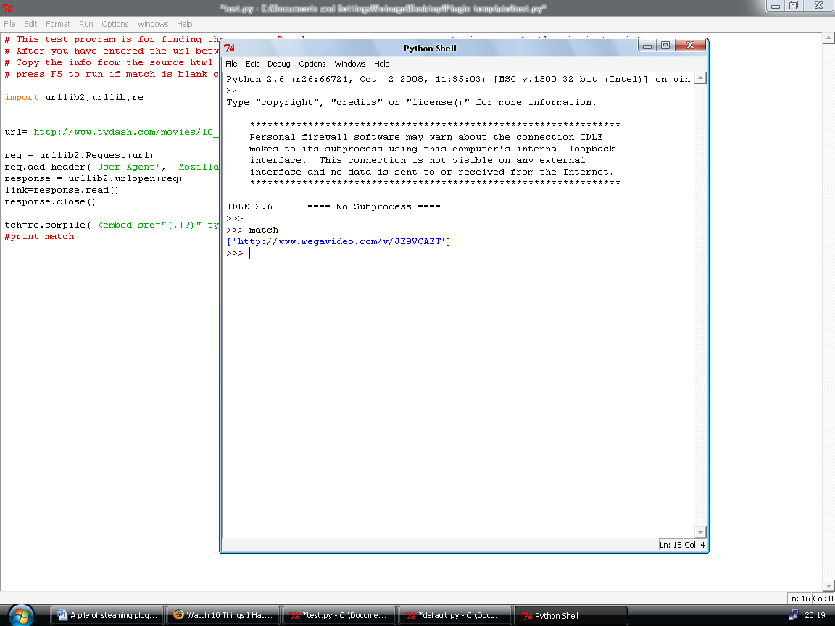

So match[0] now holds the url.

Unfortunately, Xbmc cannot follow this type of link as it calls a hidden swf file.
Xbmc needs a directly resolved link.

http://www723.megavideo.com/files/c7302786700985d0f6ea102f556dae8b/

We will find that later, for now, copy the RE from match=re.compile(‘ here ’) in test.py
Restore Default.py and paste into the match=re.compile(‘ here ’).findall(link)
in VIDEOLINKS (url,name)

If this was a direct link to an flv or an avi you would use

for url in match:
addLink(name,url,'')

or just simply:-

addLink(name,match[0],'')

As we need a resolved Megavideo url let`s press on.

Open up Videoroutines.py you should see a very scary looking set of routines.

Don`t panic

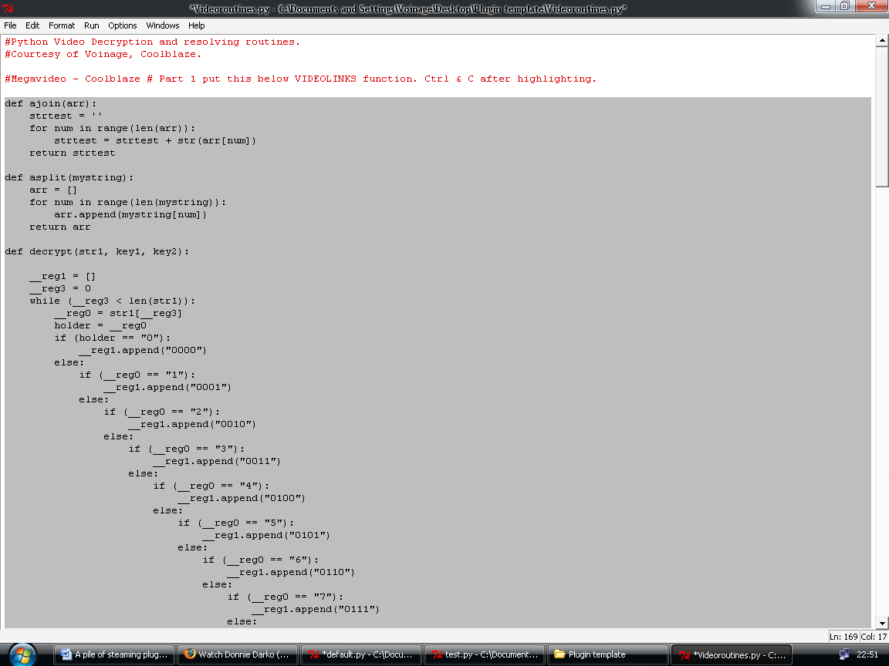

Highlight and copy part 1 then restore Default.py and paste it below VIDEOLINKS(url,name)

It starts with def ajoin(arr) and ends with return endstr.

Great, at this point don`t try to understand it , it`s quite frightening.

The next step is to copy part 2, so back to Videoroutines.py and copy part 2 with Ctrl & C
Restore Default.py and paste it below part 1.

Ok that`s the Megavideo routine in place, what it does is call up a hidden page that Megavideo use for information on their files. Scrape the information and use it to decrypt and resolve the Flv file.

A round of applause for Coolblaze of Xbmc forums and other fame, hurrah !

For now, close all open Python windows.
Restore your browser and click on ‘ MOVIES ’ scroll down until you find ‘ Streets of fire (1984) ’

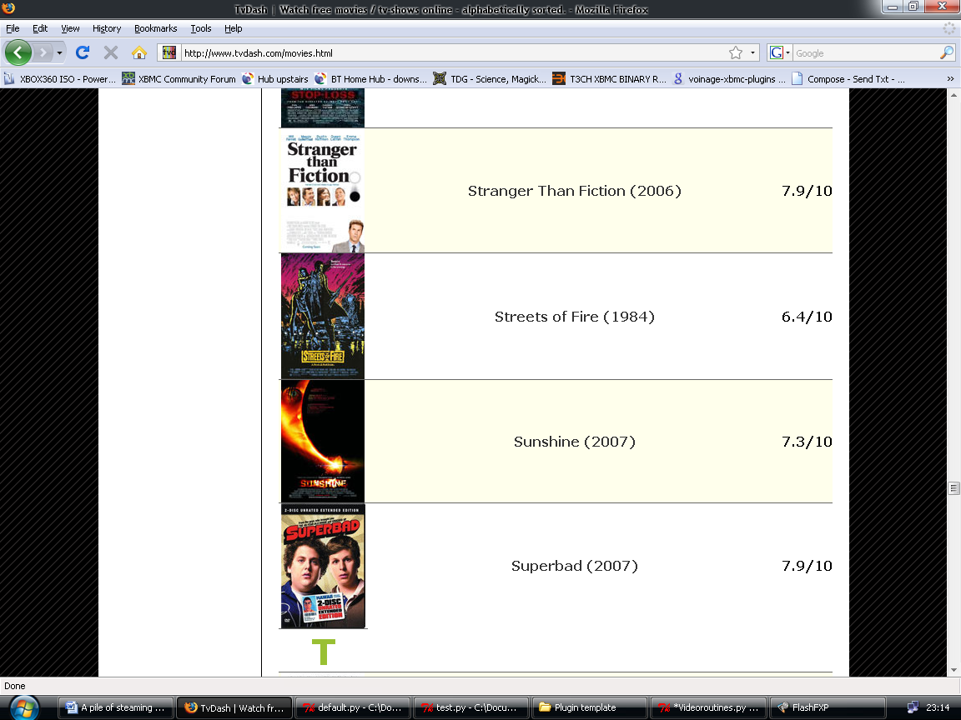

Click on it. Whoa, a new video provider. It`s StageVu – thankfully they use direct links.
See the download link..... hmmmmm
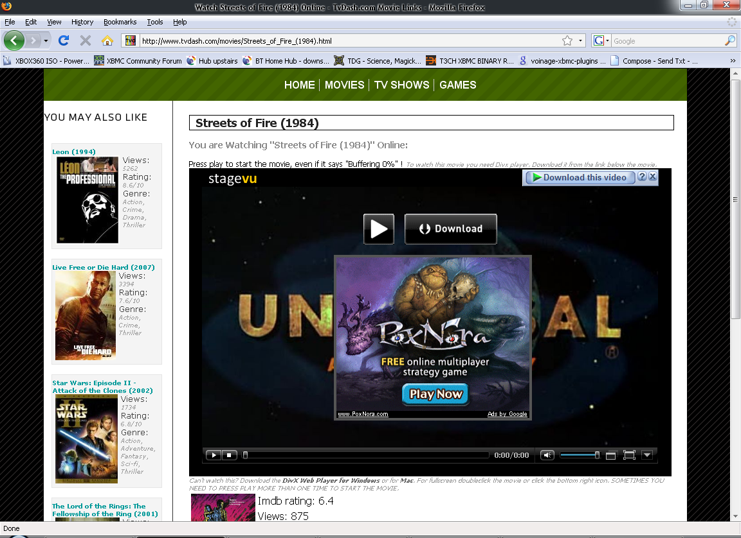
I will help you a bit here as it isn`t as easy as it seems.

View source
Ctrl & f
Look for stagevu

<iframe style='border: 0; width: 750px; height: 480px' src='http://stagevu.com/embed?width=720&amp;height=405&amp;uid=hugygadfizom' scrolling='no'></iframe>

This is different than the Megavideo RE.

<embed src="http://www.megavideo.com/v/JE9VCAET" type="application/x-shockwave-flash"

Also our Videolink(url,name) is coded for the Megavideo format.

Right.

We need to change the Function, but for now open test.py right click and → Edit with Idle.
Restore your browser and copy the url from the address bar.
Select test.py and replace the old url with the new one. Ctrl & V
Press ‘ F5 ’ and type >>>match ←ENTER
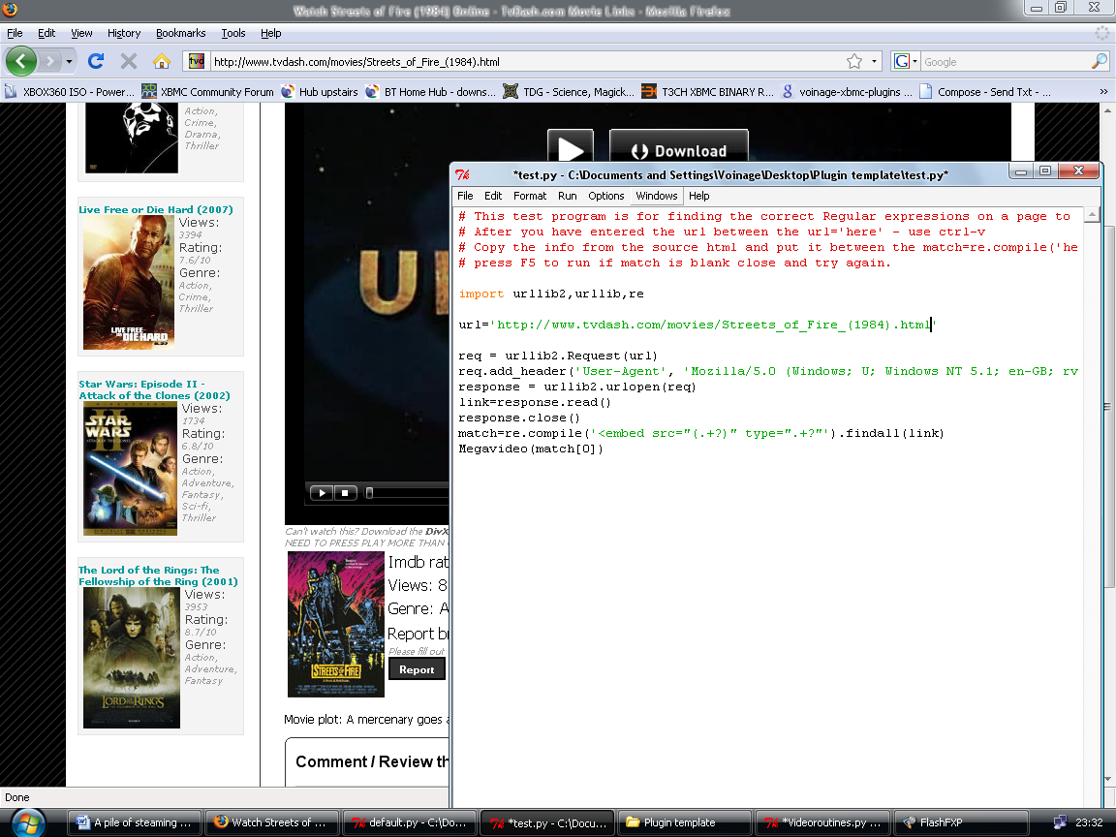

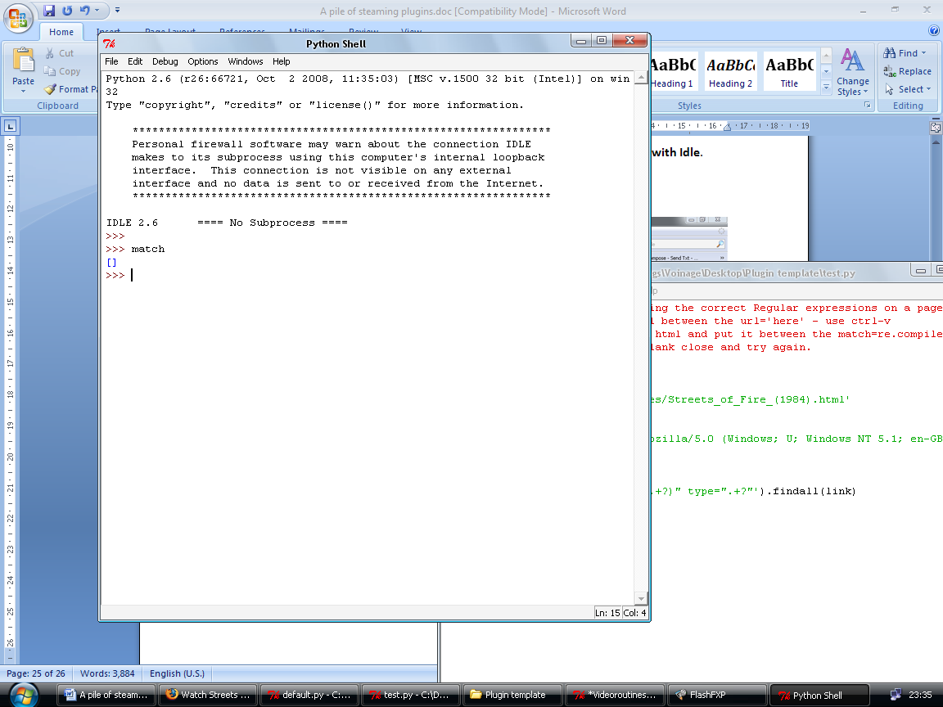

match comes up empty, the RE is different.
Remember the len() command from earlier, it`s time to use it.
Close the Python shell and restore test.py and press ‘F5’ type >>>link ←ENTER

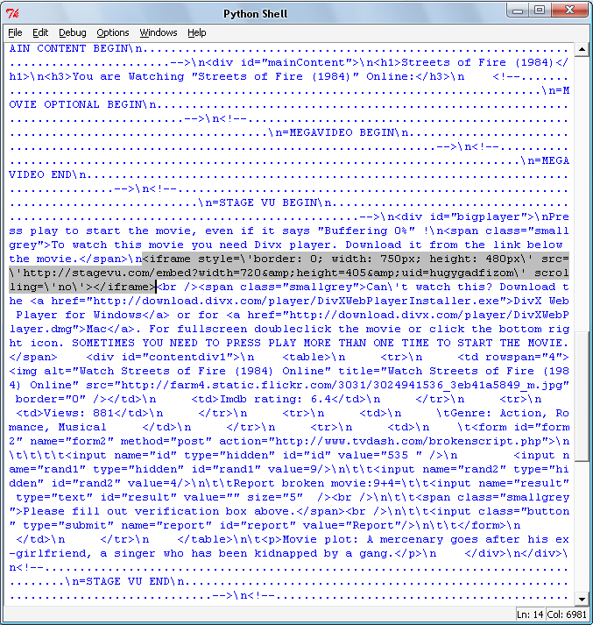
Try Ctrl & f then ‘stage’ , anything ?
Just a beep. They have tried to stop
you finding the link.

Scroll up until you find the highlighted section. It`s in yellow on the above page if you cannot see the image. Copy it. Close the Python shell. Restore test.py

Under the last match type

if len(match)<1: press ENTER

All it means is that if the length of match is less than 1 and the : tells Python that the instruction is completed. See how Python uses tabs, this is correct don`t worry.
Try leaving the : out and press ENTER , see what happens.
This will lead to an error , press ‘F5’

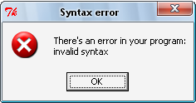

Python likes Colons.

Press OK and put the : back.

Next after checking the tabs, type

match=re.compile('').findall(link)

Paste the copied text between the single quotes. You should have :

match=re.compile(' <iframe style=\'border: 0; width: 750px; height: 480px\' src=\'http://stagevu.com/embed?width=720&amp;height=405&amp;uid=hugygadfizom\' scrolling=\'no\'></iframe>').findall(link)

Delete the Yellow highlighted text and replace with (.+?)
Below is what you test.py should look like, press ‘F5’

import urllib2,urllib,re

url='http://www.tvdash.com/movies/Streets_of_Fire_(1984).html'

req = urllib2.Request(url)
req.add_header('User-Agent', 'Mozilla/5.0 (Windows; U; Windows NT 5.1; en-GB; rv:1.9.0.3) Gecko/2008092417 Firefox/3.0.3')
response = urllib2.urlopen(req)
link=response.read()
response.close()
match=re.compile('<embed src="(.+?)" type=".+?"').findall(link)
if len(match)<1:
match=re.compile('<iframe style=\'border: 0; width: 750px; height: 480px\' src=\'(.+?)\' scrolling=\'no\'></iframe>').findall(link)
match[0]=re.sub('&amp;','&',match[0])

Type >>>match
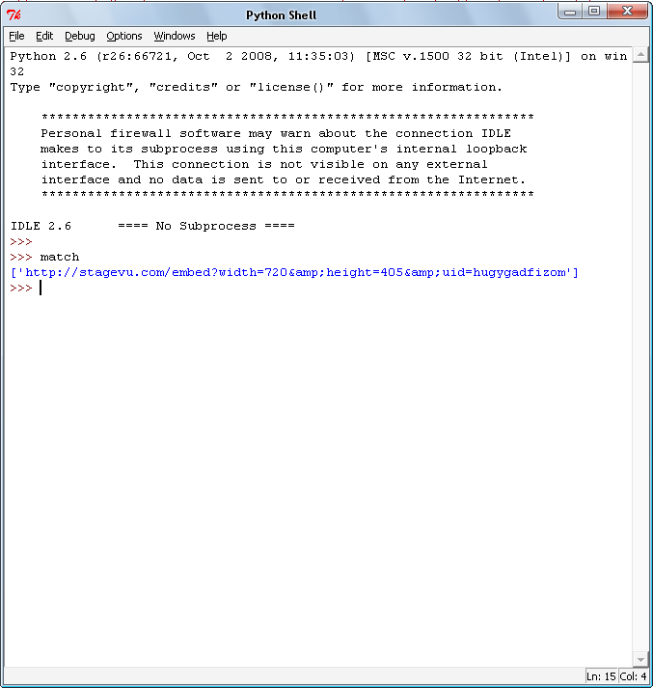

Ok, the StageVu url. No it isn`t.

It`s a link to another page because the website used a frame, hence the <iframe> tag.

Look at the link. Does it look okay ?

http://stagevu.com/embed?width=720&amp;height=405&amp;uid=hugygadfizom

Try Ctrl & click to follow the link. ‘GHOST IN THE SHELL’ , what the hell ?

The &amp; is the problem.

Welcome to the re.sub(‘ area1 ’,’area2 ’, string ) command. Regular expression substitute.

So we now have a program that checks two RE`s if the first one fails and stores the information in match. We access that with match[0] as there is only one link.

Basically swap whatever you put in area1 for whatever is in area2.
The string is whatever holds the text to be swapped, in this case match[0] it could be a text file a response.read() stored webpage, anything really.

Under the last match type: match[0]=re.sub('&amp;','&',match[0])
The whole thing should look like this.

import urllib2,urllib,re

url='http://www.tvdash.com/movies/Streets_of_Fire_(1984).html'

req = urllib2.Request(url)
req.add_header('User-Agent', 'Mozilla/5.0 (Windows; U; Windows NT 5.1; en-GB; rv:1.9.0.3) Gecko/2008092417 Firefox/3.0.3')
response = urllib2.urlopen(req)
link=response.read()
response.close()
match=re.compile('<embed src="(.+?)" type=".+?"').findall(link)
if len(match)<1:
match=re.compile('<iframe style=\'border: 0; width: 750px; height: 480px\' src=\'(.+?)\' scrolling=\'no\'></iframe>').findall(link)
match[0]=re.sub('&amp;','&',match[0])

Press ‘F5’ and type >>> match[0] ←ENTER

http://stagevu.com/embed?width=720&height=405&uid=hugygadfizom
http://stagevu.com/embed?width=720&amp;height=405&amp;uid=hugygadfizom

Bit of a difference, eh ?
Close the Python shell.
Ctrl & click both to see the difference.
Leave the new link open. Close the old one.
We now have a link to a page that has the direct link to a video file.
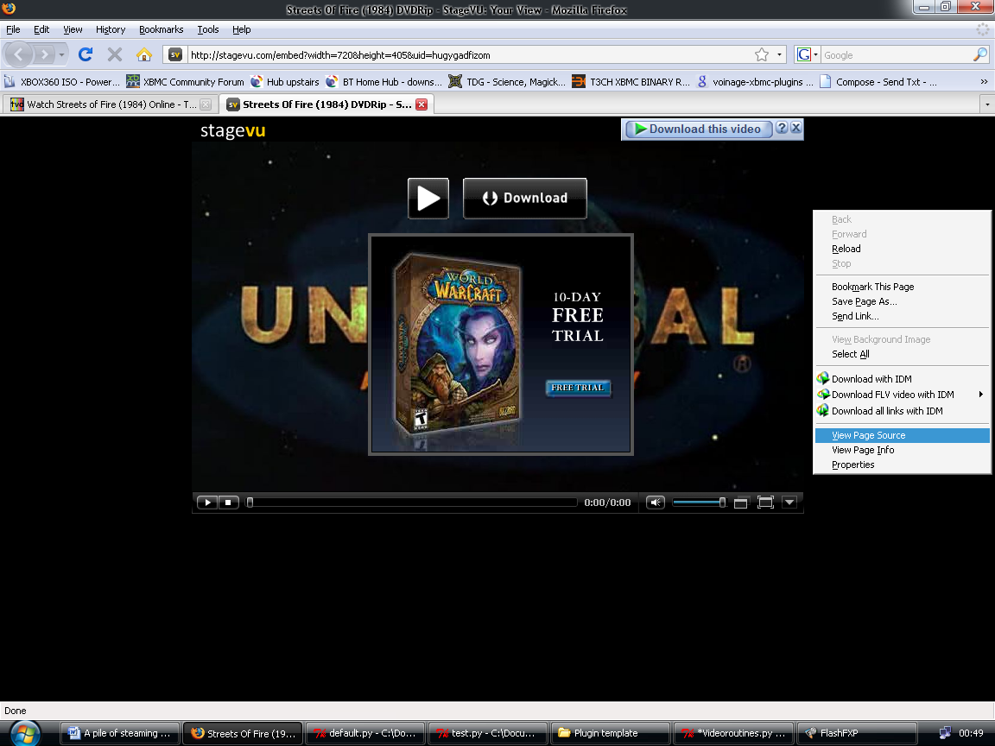
Right Click and View page source
Ctrl & F type ‘avi’ you will get three choices. Press ‘F3’ to keep searching.
<param name="src" value="(.+?)" /> is the best choice.
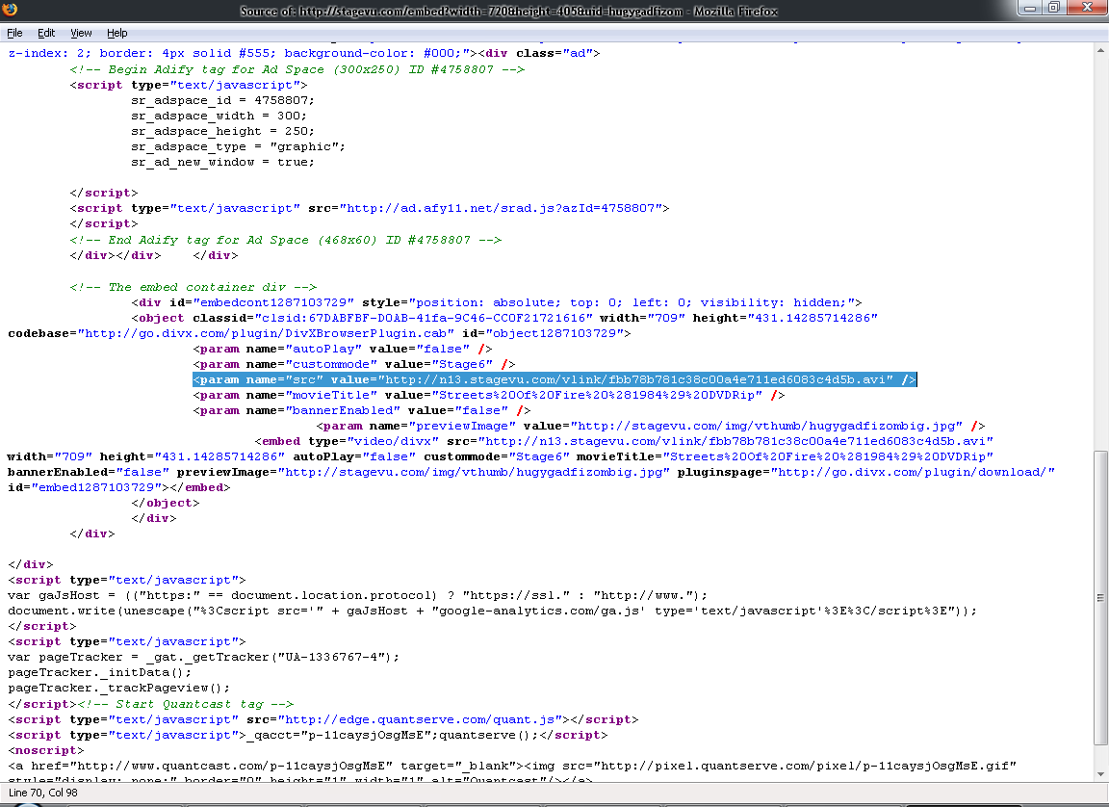

So, close the page source tab or window and restore test.py press ‘F5’
Ctrl & F type ‘avi’ and press ‘F3’ until you find the <param name= link.
Copy it and close the python shell.

It`s time to introduce basic error handling.

try:
whatever
except:
whatever

In other words try a piece of code, but, if an error occurs use another piece of code.

It`s a lifesaver.

The last time we looked at test.py it looked like this.

import urllib2,urllib,re

url='http://www.tvdash.com/movies/Streets_of_Fire_(1984).html'

req = urllib2.Request(url)
req.add_header('User-Agent', 'Mozilla/5.0 (Windows; U; Windows NT 5.1; en-GB; rv:1.9.0.3) Gecko/2008092417 Firefox/3.0.3')
response = urllib2.urlopen(req)
link=response.read()
response.close()
match=re.compile('<embed src="(.+?)" type=".+?"').findall(link)
if len(match)<1:
match=re.compile('<iframe style=\'border: 0; width: 750px; height: 480px\' src=\'(.+?)\' scrolling=\'no\'></iframe>').findall(link)
match[0]=re.sub('&amp;','&',match[0])

Well we need to change it around to include the error handling.

import urllib2,urllib,re

url='http://www.tvdash.com/movies/Streets_of_Fire_(1984).html'

req = urllib2.Request(url)
req.add_header('User-Agent', 'Mozilla/5.0 (Windows; U; Windows NT 5.1; en-GB; rv:1.9.0.3) Gecko/2008092417 Firefox/3.0.3')
response = urllib2.urlopen(req)
link=response.read()
response.close()
try:
match=re.compile('<embed src="(.+?)" type=".+?"').findall(link)
Megavideo(match[0])
except:
match=re.compile('<iframe style=\'border: 0; width: 750px; height: 480px\' src=\'(.+?)\' scrolling=\'no\'></iframe>').findall(link)
match[0]=re.sub('&amp;','&',match[0])
req = urllib2.Request(match[0])
req.add_header('User-Agent', 'Mozilla/5.0 (Windows; U; Windows NT 5.1; en-GB; rv:1.9.0.3) Gecko/2008092417 Firefox/3.0.3')
response = urllib2.urlopen(req)
link=response.read()
response.close()
match=re.compile('<param name="src" value="(.+?)" />').findall(link)
addLink(name,match[0],’’)

It seems like a big leap, it isn`t really.

You should be getting more familiar with IDLE now so change the code to resemble the above.
This will be a really good lesson in Python formatting. He he he.

Remember to press enter after each command and you shouldn`t go far wrong.
Remember to press ‘F5’ every once in a while to see if you have made a mistake.
Remember Python is case sensitive.

Python will tell you in no uncertain terms, you may hate it and this may have stopped your fun.
It`s tough love, honest.
You will thank me later.

Cheers, Vin.

Did that take a while . . . . Sorry.

What were we doing, hmmmm , yes.

Code explained.

Try : - finding a match then call the Megavideo function we dropped in earlier.
That`s right time to add it.
Its called by typing it`s name with the video link to resolve in the brackets.

Megavideo(match[0]) - Remember that Megavideo link is stored in match[0]

It takes the url that you supply and resolves it into a megavideo flv then adds a playable link.

addLink(name, movielink+'?.flv','')
Sometimes xbmc doesn`t recognize the Megavideo link is an flv so the +’?.flv’
Simply adds the ?.flv to the movielink.
Try here for more on strings : http://www.python.org/doc/2.3.5/tut/node5.html

Except: - if an error occurs, like not finding a match, then execute some new code.
Which in this case is the RE and urllib2 actions needed to get that direct StageVu link.

match=re.compile('<iframe style=\'border: 0; width: 750px; height: 480px\' src=\'(.+?)\' scrolling=\'no\'></iframe>').findall(link) match[0]=re.sub('&amp;','&',match[0])
req = urllib2.Request(match[0])
req.add_header('User-Agent', 'Mozilla/5.0 (Windows; U; Windows NT 5.1; en-GB; rv:1.9.0.3) Gecko/2008092417 Firefox/3.0.3')
response = urllib2.urlopen(req)
link=response.read()
response.close()
match=re.compile('<param name="src" value="(.+?)" />').findall(link)
addLink(name,match[0],’’)

So first we scrape the link using our new RE.
Then we fix the link with the re.sub command, but it`s a new page and we need the direct link.

So, we open and read the new page. req = urllib2.Request(match[0])
We request match[0] as that is the index representation on the link stored in match.
We then scrape it with the new RE and add a link so xbmc can play it.

The full code is available if you open and run Toughlove.py
Before you run it put a # in front of addlink as that command is only good for xbmc.
Type >>> match[0]

Direct StageVu link.
http://n13.stagevu.com/vlink/d583998babb6d14b49214f2a15f31260.avi

Right, folks time to copy the new Videolinks code over to Default.py
Close everything other than test.py and Default.py
Select Default.py :- in the VIDEOLINKS(url,name) highlight and delete the match=re.compile(‘’)

It should look like this:

def VIDEOLINKS(url,name):
req = urllib2.Request(url)
req.add_header('User-Agent', 'Mozilla/5.0 (Windows; U; Windows NT 5.1; en-GB; rv:1.9.0.3) Gecko/2008092417 Firefox/3.0.3')
response = urllib2.urlopen(req)
link=response.read()
response.close()

Select test.py and highlight and copy everything below response.close()
Back to Default.py and paste below response.close()

We should now have :

def VIDEOLINKS(url,name):
req = urllib2.Request(url)
req.add_header('User-Agent', 'Mozilla/5.0 (Windows; U; Windows NT 5.1; en-GB; rv:1.9.0.3) Gecko/2008092417 Firefox/3.0.3')
response = urllib2.urlopen(req)
link=response.read()
response.close()
try:
match=re.compile('<embed src="(.+?)" type=".+?"').findall(link)
Megavideo(match[0])
except:
match=re.compile('<iframe style=\'border: 0; width: 750px; height: 480px\' src=\'(.+?)\' scrolling=\'no\'></iframe>').findall(link)
match[0]=re.sub('&amp;','&',match[0])
req = urllib2.Request(match[0])
req.add_header('User-Agent', 'Mozilla/5.0 (Windows; U; Windows NT 5.1; en-GB; rv:1.9.0.3) Gecko/2008092417 Firefox/3.0.3')
response = urllib2.urlopen(req)
link=response.read()
response.close()
match=re.compile('<param name="src" value="(.+?)" />').findall(link)
addLink(name,match[0],’’)

Press ‘F5’ , any errors ?
If so fix your formatting.
If it`s working and formed well you should see.
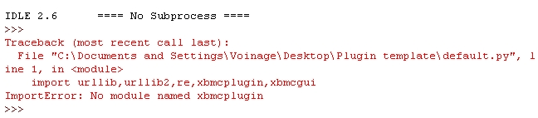

That`s fine. You will probably get : No modules named Xbmc & Xbmc etc.
I have one module running.
If you still can`t get it working use the full program : - LastResort.py
Don`t give up on getting it right if you used the Last resort !
Looking back , scanning forward.

Well folksages,

That about wraps it up.

Make a folder and name it :- Whatever you want, try Tvdash

Open your Tv Dash bookmark and Right click on the Tv Dash logo.
Select View Background image right click on the image and Save image as try default.tbn
Everytime you highlight the tvdash folder in xbmc it will display that image.

FTP the folder over to XBMC/PLUGINS/VIDEO

Enjoy your hardwork.

Thanks for reading,

Your friendly neighbourhood Voinage / Vin.

Oh , I almost forgot.

There is still a TV section, have a go yourself.

A few things to keep in mind.

The Tv section is very different and you will have to create two new functions.

Remember the modes they allow you to direct the flow of the plugin and add new functions.

Sometimes scraped urls are not the full url --- main.php when it needs to be http://tvdash.com/main.php
so in the addLink(name,’http://tvdash.com/’+url,’’) simple eh.

Pm me if you need help and try looking at the Python in my plugins for new Video routines or new plugin tricks.

I think i will release an advanced version at some point if eneough people read this one.

Rest easy Brothers and Sisters.
Voinage has left the building. (Try the Last resort.py for the full plugin with a few ????)

Thanks to Team Xbmc for a wonderful Platform.
Unbehagen for his mastery of Python and creating the Plugin system.
Guido van Rossum for creating Python.
You for reading and being enthused.

The sins of my youth.



http://www.angelfire.com/tv2/brooksidesoapbox3/gallery/jason_shadwick/index.htm

The aged St Germaine in his alembic lab... Static hairday hehe.



Try in this folder for more help with XBMC internals.

Xbmc Libs Help files & a great tutorial from Alexpoet. Thanks Alex.

